Power Apps Portals 1 Day

Power Platform WorkshopPLUS

Set-up Guide

Conditions and Terms of Use

Microsoft Confidential - For Internal Use Only

This training package is proprietary and confidential and is intended only for uses described in the training materials. Content and software are provided to you under a Non-Disclosure Agreement and cannot be distributed. Copying or disclosing all or any portion of the content and/or software included in such packages is strictly prohibited.

The contents of this package are for informational and training purposes only and are provided "as is" without warranty of any kind, whether express or implied, including but not limited to the implied warranties of merchantability, fitness for a particular purpose, and non-infringement.

Training package content, including URLs and other Internet Web site references, is subject to change without notice. Because Microsoft must respond to changing market conditions, the content should not be interpreted to be a commitment on the part of Microsoft, and Microsoft cannot guarantee the accuracy of any information presented after the date of publication. Unless otherwise noted, the companies, organizations, products, domain names, e-mail addresses, logos, people, places, and events depicted herein are fictitious, and no association with any real company, organization, product, domain name, e-mail address, logo, person, place, or event is intended or should be inferred.

© 2023 Microsoft Corporation. All rights reserved.

Copyright and Trademarks

© 2023 Microsoft Corporation. All rights reserved.

Microsoft may have patents, patent applications, trademarks, copyrights, or other intellectual property rights covering subject matter in this document. Except as expressly provided in written license agreement from Microsoft, the furnishing of this document does not give you any license to these patents, trademarks, copyrights, or other intellectual property.

Complying with all applicable copyright laws is the responsibility of the user. Without limiting the rights under copyright, no part of this document may be reproduced, stored in or introduced into a retrieval system, or transmitted in any form or by any means (electronic, mechanical, photocopying, recording, or otherwise), or for any purpose, without the express written permission of Microsoft Corporation.

For more information, see Use of Microsoft Copyrighted Content at

<http://www.microsoft.com/about/legal/permissions/>

Internet Explorer, Microsoft, Microsoft Dynamics, Microsoft Dynamics logo, and Windows are either registered trademarks or trademarks of Microsoft Corporation in the United States and/or other countries. Other Microsoft products mentioned herein may be either registered trademarks or trademarks of Microsoft Corporation in the United States and/or other countries. All other trademarks are property of their respective owners.

Table of Contents

Trial Tenant Setup 5

Sign up for a trial tenant 6

Create a Dataverse environment 12

Provision a Power Apps portal 15

Install managed solution 18

## Trial Tenant Setup

Objectives

After completing this, you will be able to:

1. Sign up for a trial Office 365 tenant
2. Sign up for a Power Apps trial
3. Provision a portal
4. Import a Dataverse solution

Hardware Requirements

* An Intel Core-i5-based PC
* 4 GB RAM•128 GB HDD
* Windows 7 SP1 or later
* **Microsoft Edge (chromium) or Google Chrome web browser** 
  + Other web browsers are not supported for Power Apps portal.
* Internet access with at least 1 Mbps bandwidth per student

Estimated Time to Complete

1. 30 minutes for the following steps

## Sign up for a trial tenant

1. If you are using Edge, open an InPrivate browsing session. If you are using Chrome, open an Incognito window. This is to ensure that you are opening a browser wherein you are not already signed into Microsoft services with your corporate credentials.
2. Navigate to [Dynamics 365 Sales Premium Trial - Sign up (microsoft.com)](https://signup.microsoft.com/get-started/signup?OfferId=82272b45-36d5-4226-8cee-576b70f7aaac&ali=1&products=82272b45-36d5-4226-8cee-576b70f7aaac&ru=https%3A%2F%2Fadmin.powerplatform.microsoft.com%2Fenvironments%3Fopen%3Dnew%26type%3DTrial%26template%3DD365_SalesPremiumTrial)
3. Enter your email address with your organization.  
   A screenshot of a computer

   Description automatically generated
4. You will receive a message that you are already using that email address with another Microsoft service. **Do not sign-in.** Instead, click on **Set up account instead**.

1. Enter your **First Name, Last Name, Business phone number, Company Name** (I recommend using something fictitious)**, Company size, and Country or region.** Click **Next**.  
   A screenshot of a computer

   Description automatically generated
2. Validate that the phone number you have entered is a number from which you can receive a verification code via text or call. Click S**end Verification Code**.

1. When prompted, enter the verification code that you received via text and click **Verify**.
2. Enter a unique, fictitious business domain when prompted in the screen indicated below and a username and password. Then click **Check availability**, and once you have verified the domain it is available and the passwords match and meet the complexity standard, click on **Next.**

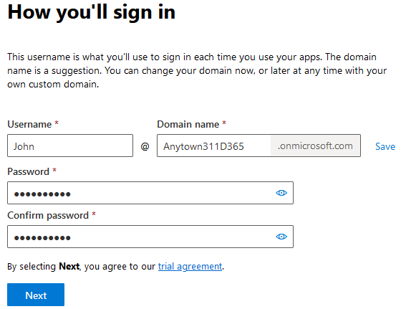

1. You will receive a success message. **Click the Save or Print button to download the login credentials that you just created!**

Click the Start using Dynamics 365 Sales Premium Trial button.

## Create a Dataverse environment

1. You will be taken to the [Power Platform Admin Center](https://admin.powerplatform.com) and should be asked to create a new Environment in the flyout window on the right. If you don’t see this window, click the +New at the top.
2. In the name field, enter Anytown 311. Click the Next button at the bottom  
   A screenshot of a computer

   Description automatically generated
3. Click the +Select button in the Security Group section  
   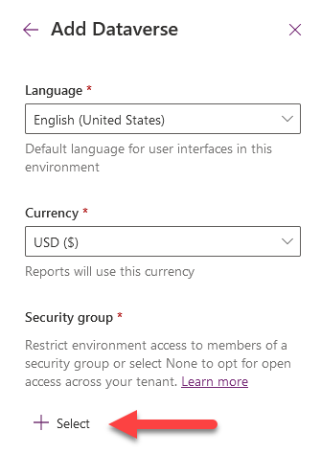
4. Select None, then click Done  
   A screenshot of a computer

   Description automatically generated
5. Click the Save button at the bottom
6. Your Environment will start creating. Once completed, the State will show Ready. You may need to refresh to see the changed status.  
   A screenshot of a computer

   Description automatically generated

## Power Apps portal

1. Open a new browser tab and navigate to <http://make.powerpages.microsoft.com>
2. In the top right of the screen, choose your environment that you had just created  
   A screenshot of a computer

   Description automatically generated
3. Click the Get Started button to start creating a new Power Pages site  
   A screenshot of a computer

   Description automatically generated
4. Click the Skip button at the bottom and select the Starter Layout 1 by clicking the Choose Template button  
   A screenshot of a website

   Description automatically generated
5. In the **Give your site a name** field, enter Anytown 311 (Portal)
6. You can leave the default **Create a web address** field or enter a unique web address, then click the Done button.
7. You should now see your site being created. This process will take about 30 minutes or more to complete.  
   A screenshot of a computer

   Description automatically generated

## Install managed solution

A [solution](https://docs.microsoft.com/en-us/powerapps/maker/common-data-service/solutions-overview) is used to transport components between environments. For the purposes of this workshop, we have created some components that we will be using in the labs for you already.

1. The Microsoft Customer Engineer will have provided you with a solution .zip file containing the name **Portal1Day**. Download this.
2. Once the Power Pages site has finished, on the lefthand side of the page, click the Solutions button  
   A screenshot of a computer

   Description automatically generated
3. Click the Import Solution in the top left command bar  
   A screenshot of a computer

   Description automatically generated
4. Click the Browse button and select the Managed Solution file that was provided to you. Then click the Next button.  
   A screenshot of a computer

   Description automatically generated
5. In the next screen, click the Import Button.   
   A screenshot of a computer

   Description automatically generated
6. After approximately five minutes you will see a message stating that the solution has imported successfully.

You have completed all the prerequisite actions required for this workshop!